Flitwick Lower School
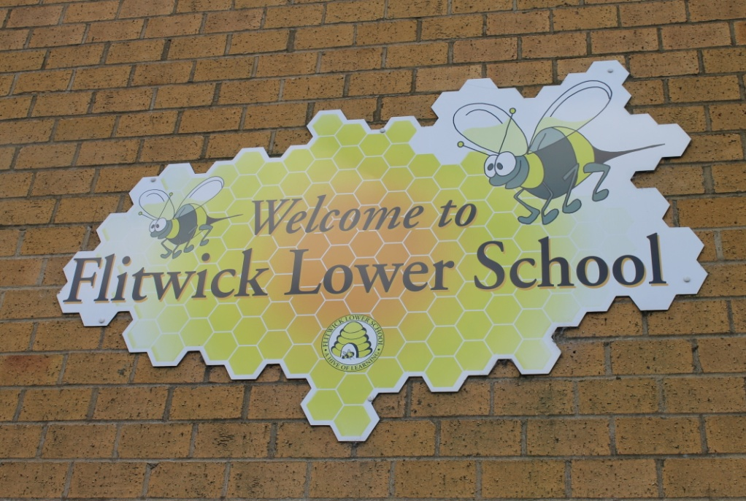
Prospectus 2018-19

A HIVE OF LEARNING
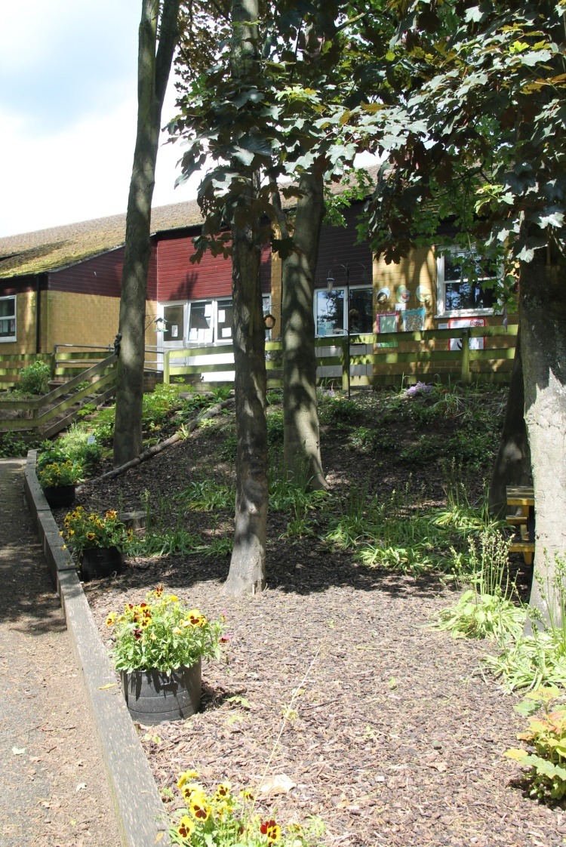

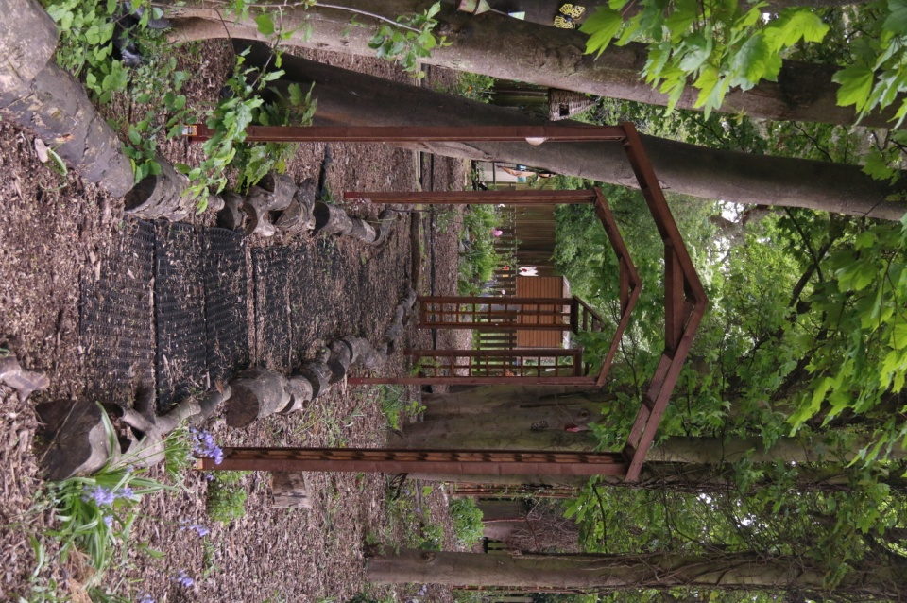

Flitwick Lower School – Community School
Temple Way
Flitwick MK45 1LU
Telephone: (01525) 755444
Fax: (01525) 755446
Email: flitwicklower@gmail.com
Website: www.flitwick-lower-school.net

Dear Parents and Carers
Welcome to Flitwick Lower School. I am delighted that you have decided to show an interest in our school.
We hope you will come to regard the school as your school and that your family’s involvement with the school will always be positive. The children, staff and parents are warm and welcoming and enjoy participating in the life of the school. We are a community school which is evident through our links with the local and wider community.
We aim to provide a happy, secure and stimulating environment in which your child will grow. Each child is valued as an individual and our curriculum is designed to provide your children with the best opportunities for learning and to make learning fun. We believe that all children need a key skills-set to develop their potential and to make their life dreams become a reality. We encourage the children to see the school as an integral part of their community and as an extension of their home. Through our focus on Values, children are taught to care for one another and the wider community as they progress through the school.
We value you, the Parents and Carers, as your child’s first educators and we work in partnership with you to ensure that your child/ren have the best start to their education. We want to continue to strengthen this partnership between home and school.
This booklet sets out some information about our school which we hope you will find useful.
On behalf of the governors and staff of the school, may I extend a very warm welcome to you and your child and look forward to meeting you.
Yours sincerely

Joanna New
(Head Teacher)

About us.......
Flitwick Lower School caters for pupils from 4 to 9 years old from a wide area across Flitwick. Our school is set in grounds of just over three acres, to the west of Flitwick town centre. There is a Foundation Stage Unit and ten bright and airy main school classrooms. The school has a large assembly hall, an ICT suite and a purpose built library.
Flitwick Lower School opened in 1981 and we celebrated our 30th Anniversary in May 2011.
At Flitwick Lower School we believe in an inclusive approach to education and provide a caring environment where every child is helped to achieve their full potential. We believe that healthy, active children are more likely to achieve success and encourage our pupils to stay healthy through a range of activities and our school curriculum.
We are a values based school and through our core values of Friendship, Resilience, Inclusivity and Respect alongside a focus on British Values we create an environment which allows every child at Flitwick Lower to have an excellent start and fulfil their future potential through education.
At Flitwick Lower School we aim to:
- Provide a rich and exciting curriculum which engages and stimulates children so that everyone can develop fully as an individual and achieve their full potential
- Provide opportunities for every child to feel part of and be able to contribute to the school, local and wider community through the teaching of values
- Develop motivated, inspired, capable children who have a love of learning and are curious to know more
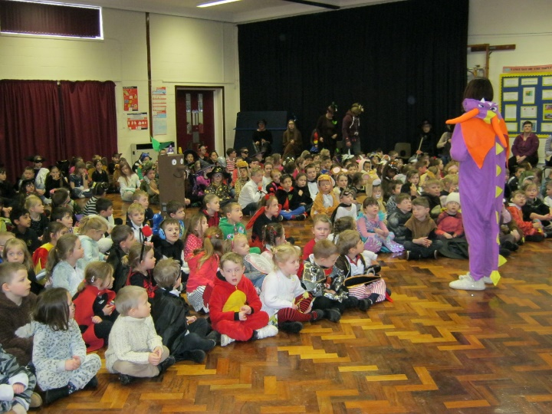
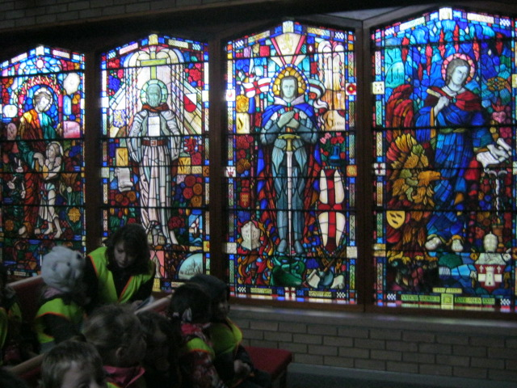
- Provide a secure and supportive environment where children can develop respect for themselves, others and their surroundings
Admission Arrangements
Children are admitted into school in accordance with the Central Bedfordshire admission guidelines. The published admissions number for September 2017/18 is 60.
Parents are sent admission booklets and forms directly from the Local Authority (LA) during the year preceding entry into Foundation. These booklets give full details of how to apply, the LA’s admissions policy for community schools and the deadlines which must be met.
Children applying for places on a “casual” basis, for example when moving into the area, have to follow the LA guidelines. School staff will explain this process and give you the appropriate forms.
If the number of places in a particular year group at the school is not sufficient to meet the requests of all the parents, the LA will then apply the following criteria in rank order, as shown, to determine how the places will be allocated.
- All ‘looked after’ children or children who were previously ‘looked after’.
- Children living in the catchment with siblings at the school.
- Children living in the catchment area.
- Other children with siblings at the school.
- Children who live nearest the school determined by straight line distance from the school site to the child’s home address.

At Flitwick Lower School we have a Foundation Unit which caters for children in their 4+ years. In line with Government legislation all children are offered a full time place from September, however, there is a part time option if parents feel this is appropriate. If your child is non statutory** there is also the option to defer entry until they reach statutory school age.
** The start of the term after their fifth birthday.

School Organisation
We are proud of the learning environment our school offers.
Flitwick Lower School is spacious, set within extensive grounds, including a large playing field, playgrounds and a conservation area. The school is bound by a security fence with just three controlled access points which are secured during the school day. There are coded locks on all external main doors.
In addition to the main classrooms, we have a large hall which has a stage area for productions and assemblies. Each class area has a large open space for classes to work together and each pair of rooms is joined by a quiet room for small group and specialist teaching.
The library is used by all the children to select and take home library books, which are scanned in and out of the computerised system.
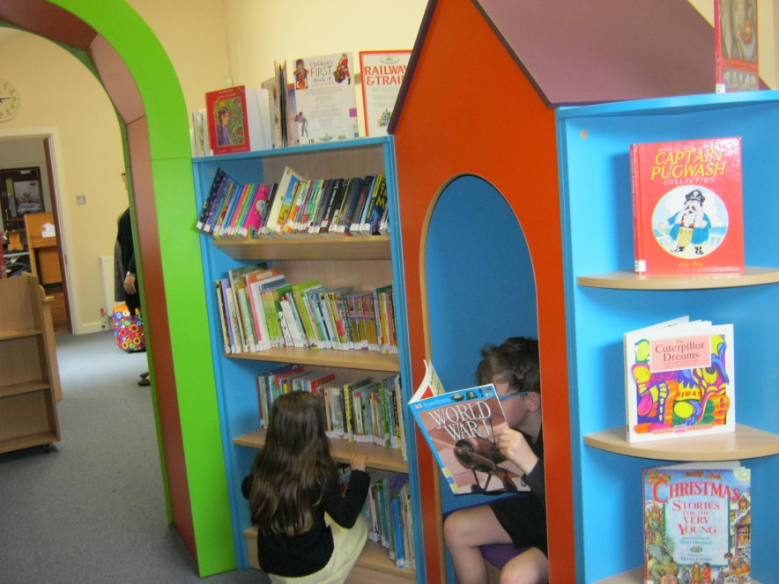
The Foundation Unit is situated in its own building, with three well equipped rooms. They have an extensive outside area which is separated from the main playground by a secure fence and comprises of a large grassed area with plenty of shade, a hard area and a covered area for outdoor activities all year round. The children are fully integrated with the main school using all the facilities including visiting the library and ICT suite.

Settling Into School
Before your child starts at Flitwick Lower you will be invited to an information evening to find out about the transition into school. You will have the opportunity to discuss any concerns you may have and get to know the adults that will be working with your child. Your child will be invited to an introductory session to help them become familiar with their new surroundings as well as member of the Foundation team visiting you and your child at your home to get to know them even better.
The School Day
Foundation Unit Years 3 and 4
Morning: 8.50am – 11.50am Morning sessions 8.50am – 12.25pm
Afternoon: 1.20pm – 3.30pm (with morning break of 15 minutes)
Afternoon session 1.30 – 3.30pm
Years 1 and 2
Morning sessions 8.50am – 12.00pm
(with a morning break of 15 minutes)
Afternoon session 1.20pm – 3.30pm

The Curriculum
The National Curriculum specifies a Foundation Stage and two Key Stages in relation to the Lower School.
These are:
Foundation Stage 4 – 5 years
Key Stage One 5 - 7 years (Years 1 and 2)
Key Stage Two 7 – 11 years (Years 3, 4, 5 and 6)
Lower School Key Stage Two is
7 – 9 years (Years 3 and 4)
Our School Curriculum
The curriculum is tailored to meet the needs of the children, as well as the requirements of the Foundation Stage and National Curriculum. Every child learns in a different way, so teaching is carefully planned so that all are able to access the curriculum. Provision is made to learn from first-hand experience. Children are encouraged to be independent, think for themselves and grow in confidence. Progress is monitored continuously, which is shared with parents and used to identify next steps in their learning. Records are kept for each child to show the progress and achievement children have made.

The Early Years Foundation Stage
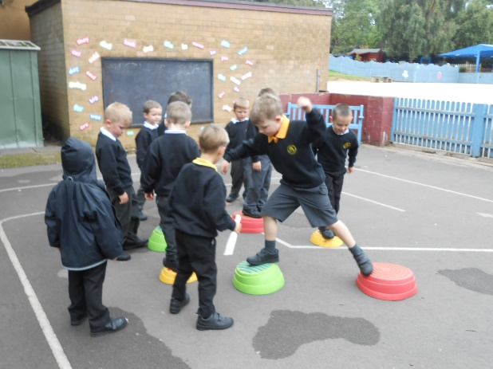
This is preliminary to the National Curriculum and focuses on the needs of children up to 5 years. It is based on 7 areas of learning.
- Communication and language
- Literacy
- Mathematics
- Understanding the world
- Personal, social and emotional development
- Expressive arts and design
- Physical Development
Activities take place both indoors and outdoors with a balance of child initiated and adult led activities. Children are encouraged to work independently and in small groups.
Key Stage 1 and 2
As children move through into Year 1 the curriculum is based on a mixture of the principle of the Foundation Stage and the National Curriculum.
At Flitwick Lower we provide a broad and balanced curriculum which is based upon the National Curriculum for all children in Year 1 and above.
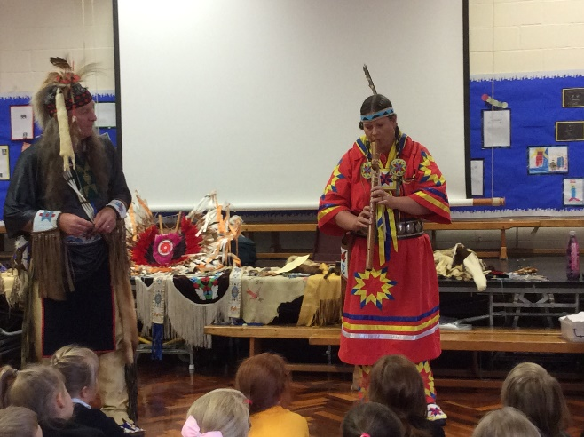
Children are taught through a cross-curricular approach and through topics or themes to make learning more meaningful for the children. Literacy is set where possible within the context for learning with specific sessions to teach Phonics. Numeracy is taught as a separate session focusing on specific skills and knowledge; however it is closely linked to everyday situations or problems. Every year group has guided reading sessions focusing on a more personalised learning process.

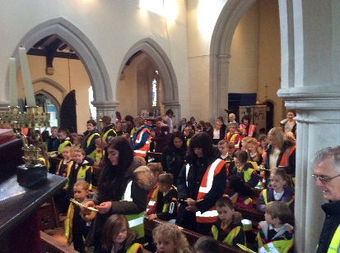
R.E.
The school follows the LA Agreed Syllabus. This allows the children to develop their knowledge and understanding of different faiths alongside the appropriate skills and attitudes.
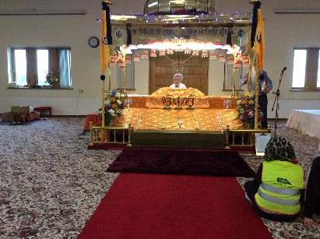
Parents have the right to withdraw their child from collective worship by putting their request in writing to the Head Teacher.

Special Educational Needs
We are a fully inclusive school with equality of opportunity for every child. A child with special needs may be any child with learning, social or physical needs that are significantly greater than the majority of children in their peer group. If you feel your child has specific needs please contact Mrs New to discuss this on further so that we can ensure your child’s needs are fully met as they start school.
The school has a comprehensive policy for special needs. We have a Special Education Needs Co-ordinator (SENCO) and there is a nominated Governor who has responsibility for monitoring special needs.
The More Able Child
More able children may show their ability in any area of the curriculum. The school caters for more able children by identifying their abilities and then differentiating the curriculum to ensure appropriate challenge. This ensures ongoing support for pupils where required.
Home School Agreement
Every child attending Flitwick Lower is given a copy of the ‘Home School Agreement’ to read and share with their parents. This outlines the agreed standards of behaviour and how we work together. It is age appropriate, with one for Foundation and Key Stage 1 and a different version for Key Stage 2.
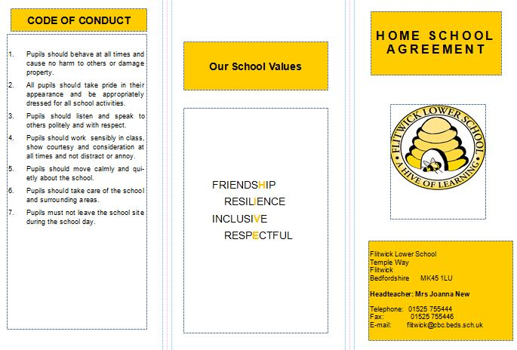
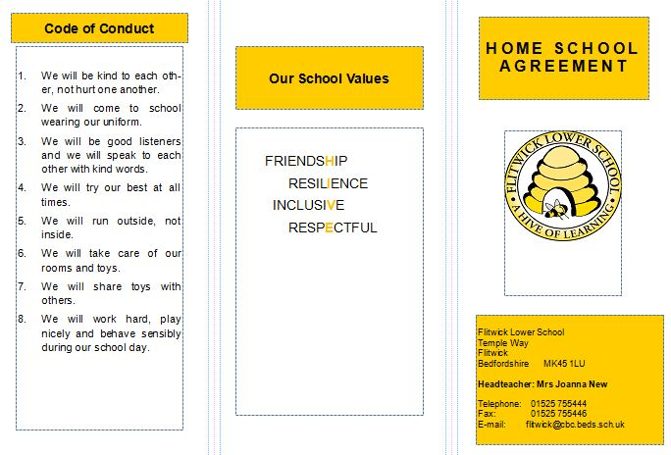

Extra Curricular Activities
Extra Curricular events directly enhance children’s learning and curriculum experiences. At Flitwick Lower, we have a wide variety, such as our annual book week, arts week, Christmas concerts, class assemblies, theme days, visits from authors or musicians and the ‘Fun Run’. Pupils participate in offsite visits; ranging from walks in the local community to annual end of year trips away from school; for instance to a local theatre, a nature reserve or the zoo. The Year 4 children all have the opportunity to attend a residential visit to Grafham Water.
In addition to the relevant educational visits and visitors to the school, there are opportunities for children to take part in a range of external festivals and events within the community.
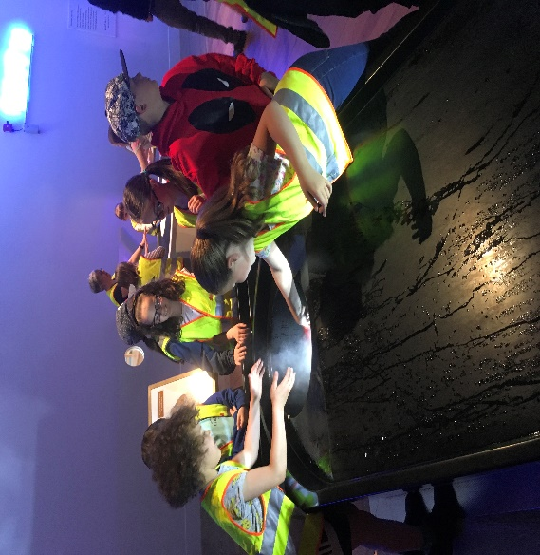

Pastoral Care and Behaviour / Bullying / Safeguarding
As a values based school, we believe that children should be taught right from wrong and understand that everyone has the right to be safe, secure and in a caring environment.
We raise children’s self-esteem through praise and positive reinforcement. At the start of each school year children discuss and agree class and school rules, which are designed to develop self-discipline and awareness of the needs of others.
We believe that parents should be informed of any persistent behaviour problems at an early stage, so that school and home can work together to give positive and constructive help.
In line with government guidelines, the school has strategies for preventing bullying and procedures for dealing with it. Parents are welcome to have a copy of the school’s behaviour policy upon request.

Parents as Partners
We are proud of our positive relationship with parents and the wider community. Staff are always available to talk to parents about their child’s individual needs, both informally and by appointment.
We communicate with parents / carers in a variety of ways. A weekly newsletter is sent home every Week, giving information about what has been happening in school and the wider community, including reminders about the week ahead. The Website is updated weekly with any letters sent home and we have a texting service which we use to remind parents of dates, events or school closures.
The ‘meet the teacher’ evening in September for Parents / Carers explains the years work, routines, procedures and our expectations. We hold formal consultation evenings twice a year and an open evening late in the Summer Term.
Every term we hold an informal viewing after school to give you a chance to look at your child’s work.
New parents are invited to school to discuss the organisation of the day and the curriculum prior to their child commencing school.
Many parents come into school on a regular or occasional basis to help with a variety of activities and their work is greatly appreciated.
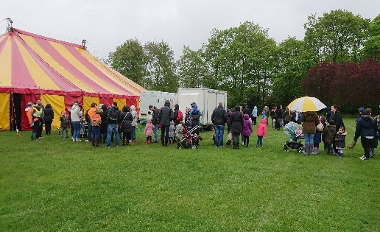
The Flitwick Lower School Association
We are privileged to have a very active Parent-Teacher organisation – known as the ‘Flitwick Lower School Association’. This is a registered charity made up of the school’s staff and volunteers from all those who have children at the school. Each year the Association is active in raising funds to enhance the education of pupils, for example by paying for theatre groups to visit the school, subsidising the cost of school trips and paying for classroom equipment.
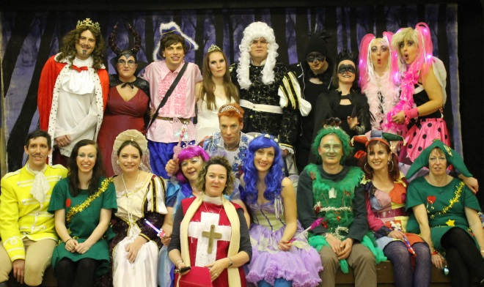
Funds are raised through events such as the annual ‘Fun Run’, bingo nights, Christmas and summer fayres and ‘the Pantomime’ which has spanned three decades and is staged in the Village Hall. We have also launched a ‘School Lottery’

Extended Schools
We provide a range of extended school services for the families in our school community.
Flitwick Lower runs a popular Beehive out of school club for an additional charge. This club is run by qualified staff and offers before and after school care, ideal for working parents. The club runs a variety of activities including crafts and cookery. There is a range of play equipment and snacks are provided.
We run a variety of lunchtime and after school clubs. The range of clubs varies, but can include ICT, Sport, Dance, Lego, Multilingual, and Gardening. Some of these clubs have a nominal charge. There is also an independent after school Drama club which operates from the school site.
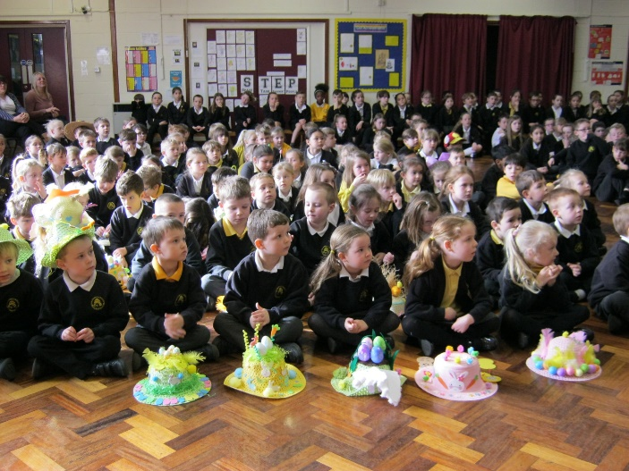
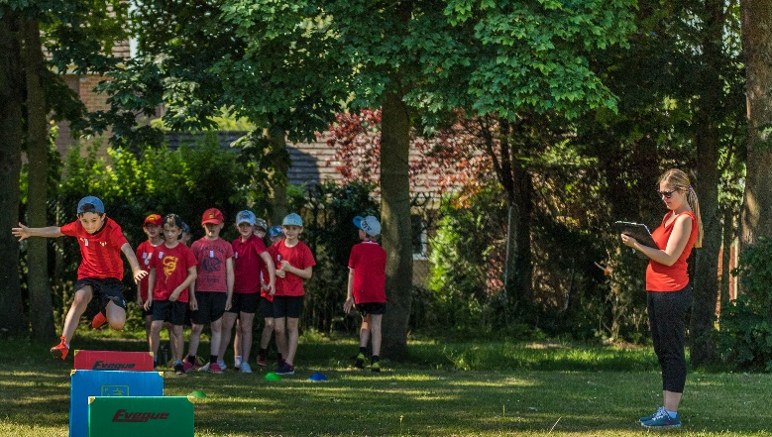

Sports Day Easter Bonnets
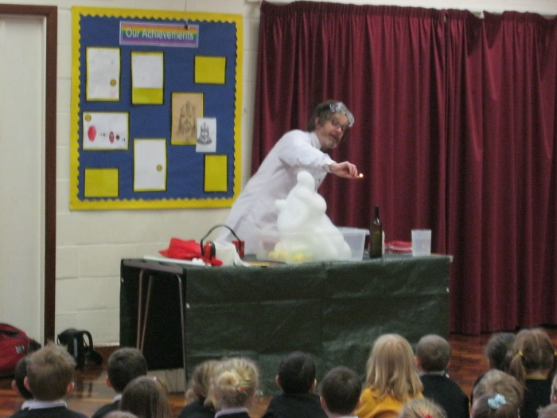
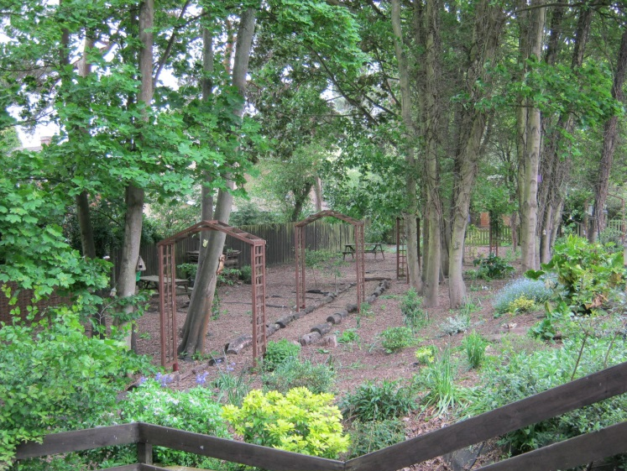

The conservation area Science Day

General Information

If your child is starting Flitwick Lower you may find this A – Z information guide useful.
Attendance
Flitwick Lower School works very closely in partnership with parents to ensure all pupils follow the School Attendance guidelines. Pupils are expected to attend school regularly and on time. The Governors are very pleased to note that most families support this. If a pupil is absent from school, parents are requested to telephone the school on the morning of absence and send a note on their return.
If this is not done, it is regarded as an ‘unauthorised absence’, as will occasions which we do not consider as a legitimate reason for the child to be away from school, e.g. shopping.

Availability of Public Documents
Under the ‘Freedom of Information Act 2000’ an person has the legal right to ask a holder for access to the information it holds. Many school documents are available either through the school website at www.flitwick-lower-school.net or by contacting the Head Teacher.

Charging for School Activities
As required under the ‘Education Reform Act 1988’, the school has a policy for the charging and remission of charges for school activities. The act confirms the principle that education during school hours should be free of charge, but it does not prohibit the school from seeking voluntary contributions to pay for school outings etc. There is no obligation to contribute and pupils will not be treated differently according to whether or not their parents have made a contribution.

Complaints
Most complaints are best dealt with informally. If there are any concerns regarding the school or the education provided please make an appointment to discuss the matter with the child’s class teacher. Should a matter not be resolved informally despite meetings with the class teacher, Key Stage Leader, Assistant Head Teacher or Head Teacher, then the school has a formal complaints procedure, monitored by the Governing Body. For further details please contact the Head Teacher.

Child Protection and Safeguarding
As a school, we have a statutory duty to assist Children’s Services departments acting on behalf of pupils in need or enquiring into allegations of child abuse. As well as the statutory duty, we have a pastoral responsibility towards our pupils and we recognise that pupils have a fundamental right to be protected from harm. Pupils cannot learn effectively unless they feel safe and secure. We, therefore, have a Child Protection and Safeguarding Policy, which reflects both our statutory duty and our pastoral responsibilities.
In general we will seek to discuss any concerns about your child’s welfare and where possible seek your agreement before any further action is taken. However this would only be done where it would not place the child at increased risk of significant harm.

Community Cohesion
Children are taught to respect the traditions, beliefs, needs and cultures of others, both in school and in the wider community.
The School takes an active role in developing community links with all our local pre-schools, nurseries and schools. Our school receives support from local industries and businesses and a friendly supportive relationship with local religious groups. We engage with the local community in various ways; by singing carols to Flitwick pensioners, performing plays to Ferndale residents and visits to local churches.
Our School participates in fundraising events for global disasters, Children in Need and Red Nose Day. Our children also take pride in collecting food for Harvest Festival and Charity appeals which go to children who are less fortunate. The School Ambassadors help to select charities to support each year.

Equality
The school recognises its duties under the Equality Act 2010. These guidelines are outlined in detail in our Single Equality Policy.

Holidays
We hope that parents will not take children on holiday during term time as we are keen to promote the importance of school and regular attendance. There is no entitlement to take time off in term time but if in exceptional circumstances it is unavoidable then you should obtain and complete a holiday request form at least 4 weeks in advance.

Home learning
Children take home reading books home from when they start school. The Foundation children have learning logs to share at home whilst Years 1 to 4 have learning at home tasks which are linked to their learning in school but also celebrate activities and learning outside school.

Medication
We will ONLY administer prescribed medicines/tablets to your child if it is impossible for you to come into school to do this, you will need to complete and sign an indemnity form. We will NOT administer any form of pain killers such as Nurofen or Calpol.
Safety
Children should not be left unaccompanied in the playground but be with an adult until the whistle blows at 8.50am. All the perimeter gates are locked at 9.00am and re-opened at 3.15pm.
School meals
School meals are provided by Luton Borough Council, and are prepared and cooked on the premises by our school cook. There is a wide variety of wholesome food, presented and available each day. The menu always includes two hot dishes, including a vegetarian option, and a range of salads. Provision is also made for those children who wish to bring a packed lunch. Shared mealtimes are socially important and we make lunchtimes as enjoyable as possible.
On Wednesdays and Fridays those children who have packed lunch have the opportunity to try a school lunch - with Wednesday Roasts or Friday Fun Lunches.
From Foundation to Year 2 the children are now entitled to have school dinner free of charge.
School parking
We endeavour to maintain good relationships with the local residents and this is greatly helped by considerate parking.
The school car park is for staff and visitors only, so parents tend to park on the road outside school. Please park safely and considerately, especially at the beginning and end of the day when the area around school can be very busy. We want all our children to be safe.
We are part of the Park and Stride initiative with the local Tesco Supermarket. This means Parents are able to use their facilities to park when taking their children to school.

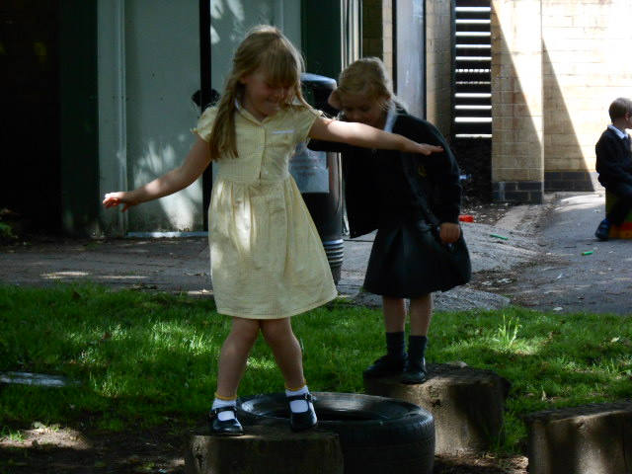
Personal Property
Please put your child’s name on all clothing.
Lost property is placed in the foyer area.
School Uniform Girls and Boys
Grey or black trousers, pinafore dress or skirt
Yellow gingham summer dress
Gold or black cardigan
Gold, black or white short-sleeved polo shirt
Black, white or grey socks or tights.
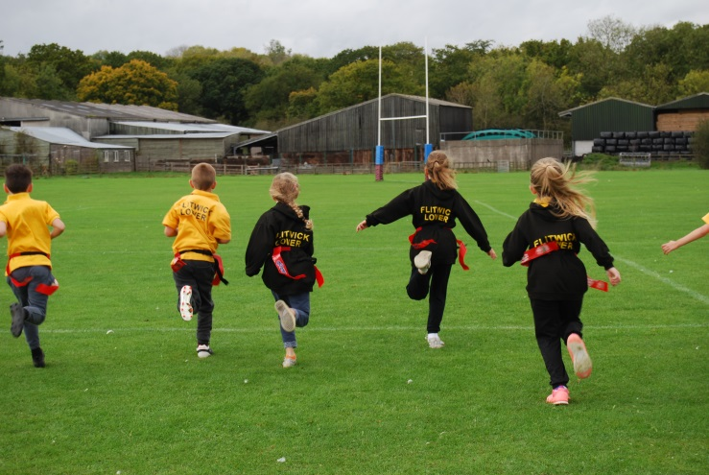
P.E kit Girls and Boys
Black shorts
A Gold or White T-shirt
Trainers for outside P.E
Other items needed are:
Book bags and a draw string bag for P.E
(Not ruck sacks)
Please note: children need a book bag from Foundation up to Year 4 – no bags bigger than book bag are allowed in school. (Please Note: All book bags are provided for New Foundation Starters)
School Uniform can be purchased through locally sourced suppliers Lowegos www.lowegos.co.uk - and Prestige www.prestigedesign.co.uk – High Street Flitwick

Moving On
Staff at Flitwick Lower work hard to ensure that children move smoothly from one stage of learning to the next. Particular care is taken for children moving up to ‘big school’ from their pre-school groups. We have a comprehensive transition programme within year groups. The curriculum design has been adapted to allow children time to settle and be comfortable with their learning environments and to make relationships with the different members of staff.
At the other end of the school, the children progressing from Flitwick Lower to middle school are also prepared for this big change. In the autumn term before transfer, parents / carers and children are invited to attend open evenings at local middle schools. Pupils living within the catchment area for Flitwick Lower are eligible for a place at Woodland Middle School. In the summer term, staff from Woodland Middle School visit Flitwick Lower to get to know the children and also to teach them, allowing children to experience middle school lessons in the familiarity of their own classroom.
What To Do Next?
We have an ‘open door’ policy, if you would like to visit please contact us to make an appointment to look around the school.
Visit Flitwick Lower on one of the termly open days to see the school in action, view our resources and experience the happy atmosphere. The office staff will be able to let you know when the next open day is scheduled.
Visit the Flitwick Lower website at www.flitwick-lower-school.net

